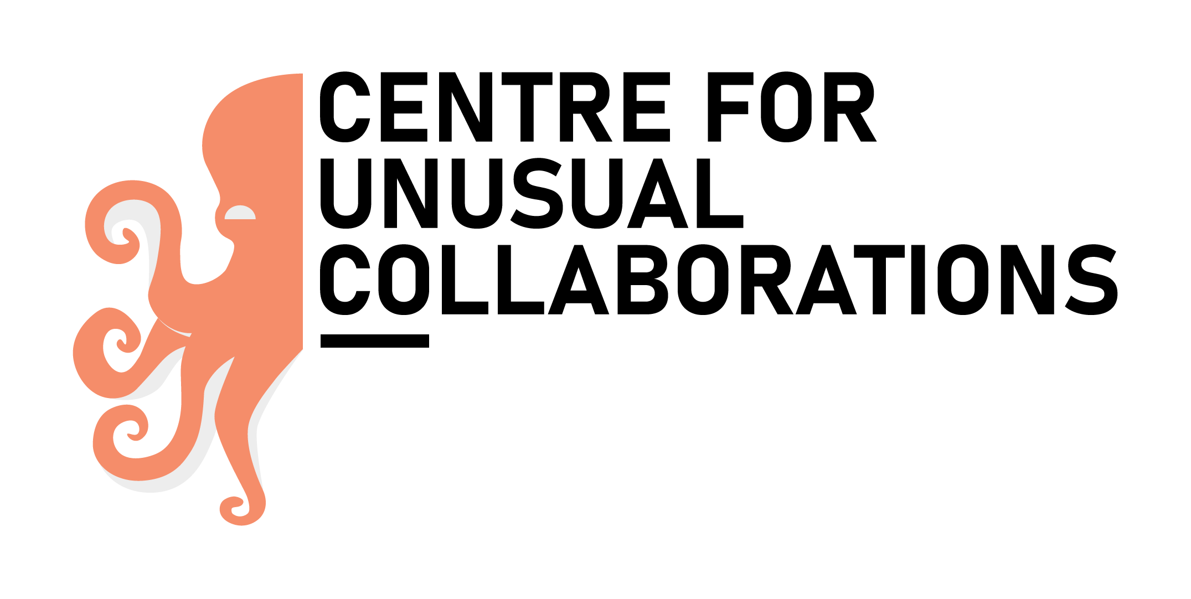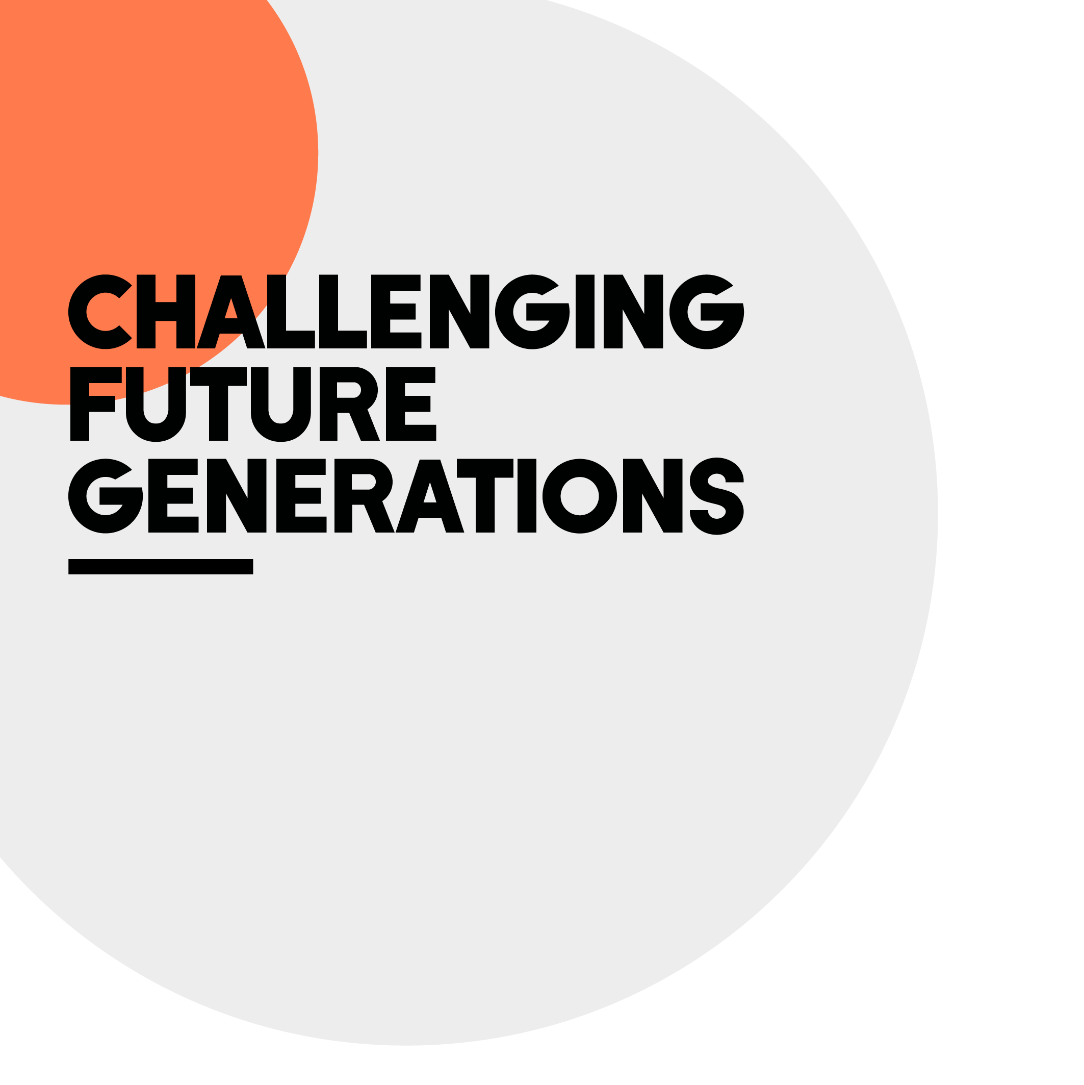

**Submission form to participate to the ART EXPOSITION on**

**FERTILITY and REPRODUCTIVE HEALTH**

Please complete this form and upload your artwork(s) to wetransfer.com and send us the filled form and the link for download to the following address: [m.villani@uu.nl](mailto:m.villani@uu.nl)

Full name:

Email address:

Describe who you are (e.g. scientific researcher, student, patient, nurse…):

Field of expertise (optional):

Title of you artwork:

Tell us about your artwork: What do we see? Where did you get inspiration from? What techniques/tools did you use?

How does you artwork connect with the theme FERTILITY and REPRODUCTIVE HEALTH? what is the message that you would like to express?

