APPLICATION FORM
CUCo Fellowship Programme:
Collaborative Leadership in Transdisciplinary Research
Are you an early- or mid-career academic interested in exploring new ways to address the pressing challenges of our age? After a period of strategic reflection, the Centre for Unusual Collaborations is excited to launch its Fellowship Programme, a one-year learning journey into collaborative leadership in transdisciplinary research. With the Fellowship Programme, CUCo equips you with the virtues, sensibilities and skills to lead unexpected and innovative transdisciplinary collaborations.
To apply, please complete the following form and submit it together with your CV and letter of recommendation from your supervisor. The application deadline is Wednesday, July 1, 2026. Please don’t hesitate to contact us at cuco@ewuu.nl if you have any questions.
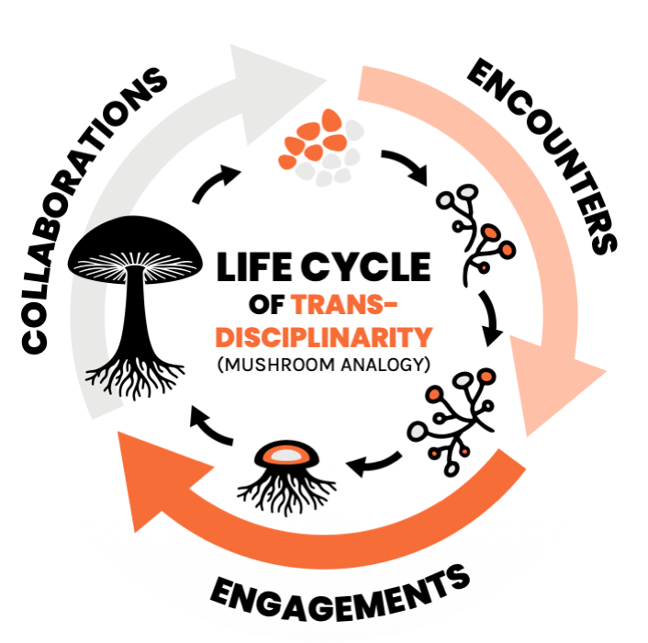
Originally published in van Paassen et al. (2024) Scoping Transdisciplinary Collaborations. CUCo.

- WHO ARE YOU?
Full name
Preferred pronouns
Department/Faculty
Institute | r Eindhoven University of Technology  r Wageningen University & Research  r Utrecht University  r University Medical Centre Utrecht
Career stage | For instance: Postdoc, Assistant Professor, Associate Professor, Researcher, Lecturer
Disciplinary background | You may refer to different stages of your training and career, as well as inter- and transdisciplinary work you have done  (Maximum 100 words, please include word count)
Epistemological background | How would you describe the epistemological tradition that you identify with most strongly? E.g.: do you usually collect data through quantitative or qualitative methods? How do you validate methods and results?  (Maximum 100 words, please include word count)
How did you find out about the Fellowship Programme? | For instance: through a newsletter or a colleague
Overview of required application documents | r Completed application form  r CV  r Letter of recommendation from supervisor/department head

- TRANSDISCIPLINARY EXPERIENCE, INTERESTS & ENGAGEMENTS
CUCo uses the analogy of the mushroom cycle to discuss what makes transdisciplinary collaborations successful. Stepping outside your comfort zone, asking different kinds of questions, embracing creativity, and remaining open to serendipitous encounters can all stimulate meaningful new collaborations. Often, this takes time, much like the mycelium, the underground network of germinated spores that needs a nurturing environment before a mushroom can emerge. The same is true for transdisciplinary work: the real groundwork—finding the right partners, building trust, and developing relationships—usually happens quietly, long before a formal project begins.

Please share your experiences laying the groundwork for transdisciplinary collaboration.

What is your experience with transdisciplinary collaborations? How would you describe your level of experience?  If you haven’t yet participated in a transdisciplinary collaboration, what interests or compels you to want to start? | (Maximum 300 words, please include word count)
Please share a specific challenge or opportunity you see or have personally experienced in relation to transdisciplinary collaborations. | (Maximum 300 words, please include word count)

- MOTIVATION & LEARNING OBJECTIVES
CUCo offers an experimental space for things that cannot easily exist in the current academic system. What would you like to explore and develop within this space? Who would you like to be(come) as an academic and what intellectual community are you seeking to support you in this journey?
In addition, please formulate 1-3 specific learning objectives or goals you would like to achieve during the Fellowship Programme. This will help tailor the fellowship sessions to your needs. The (optional) self-assessment tool we have developed can help you identify what you care about/are interested regarding collaborative work.
Motivation: what would like to explore and develop? Who would you like to be(come)? | (Maximum 300 words, please include word count)
Learning objectives | (1-3 specific learning objectives or goals for this fellowship: maximum 300 words, please include word count)

- COMMITMENT
By submitting this application, you are signalling your commitment to completing the Fellowship Programme. We will shape the contours of this programme together as a group and active participation is essential. Should you be selected as a participant, we expect you to attend every session.
To facilitate this commitment, CUCo will finance the hours you will spend at the sessions.
If you have agenda conflicts related to prior commitments or obligations you absolutely cannot change, please list them below.
Agenda conflicts | Are there any sessions that you cannot attend due to prior commitments or obligations that absolutely cannot be changed?
Salary scale and increment | Please indicate your current salary scale and increment to help us budget the hours that will be reimbursed to your department.
Budget code and controller | Please include the budget code to which your hours should be reimbursed, and the name and email address of your departmental controller should we have any finance-related questions.

After applying, make sure to pencil in all the session dates listed below.

Date | Session | Location
Friday, September 11, 2026 | Kick-off session (two hours) | Online / Teams
Friday, October 9, 2026 | Session #1 | Utrecht
Thursday November 5 (from 16:00) - Friday, November 6 (16:00), 2026 | Session #2 (24 hours) | Wageningen
Friday, December 4, 2026 | Session #3 | Eindhoven
Friday, January 8, 2027 | Session #4 | Utrecht
Friday, February 5, 2027 | Session #5 | Wageningen
Friday, March 5, 2027 | Session #6 | Eindhoven
Friday, April 9, 2027 | Session #7 | TBD
Friday, May 14, 2027 | Session #8 | TBD
Friday, June 18. 2027 | Session #9 | TBD
Friday, September 17, 2027 | Final event | TBD

For instance, a positivist epistemological approach: Knowledge can present an accurate representation of that object by describing and explaining its regularities and can possibly predict its behavior. Theories present ‘models’ that reveal empirical regularities and generalize causal relationships between them across different circumstances. Or a constructivist epistemological approach: Knowledge is an attempt to understand the mental, social and cultural phenomena that shape humans’ diverse subjective perceptions of reality, meaning-making and behavior. Knowledge comprises (revisable) evaluative ideas that offer frameworks used to sort out humans’ complex social relations and processes.

